**A BLOG ON HTTP 1.1 vs HTTP 2**

#### **What is HTTP/1.1?**

The first usable version of HTTP was created in 1997. Because it went through several stages of development, this first version of HTTP was called HTTP/1.1. This version is still in use on the web.

#### **What is HTTP/2?**

In 2015, a new version of HTTP called HTTP/2 was created. HTTP/2 solves several problems that the creators of HTTP/1.1 did not anticipate. In particular, HTTP/2 is much faster and more efficient than HTTP/1.1. One of the ways in which HTTP/2 is faster is in how it prioritizes content during the loading process

## **What is prioritization?**

In the context of [web performance](https://www.cloudflare.com/learning/performance/why-site-speed-matters/), prioritization refers to the order in which pieces of content are loaded. Suppose a user visits a news website and navigates to an article. Should the photo at the top of the article load first? Should the text of the article load first? Should the banner ads load first?

Prioritization affects a webpage's load time. For example, certain resources, like large JavaScript files, may block the rest of the page from loading if they have to load first. More of the page can load at once if these render-blocking resources load last.

In addition, the order in which these page resources load affects how the user perceives page load time. If only behind-the-scenes content (like a CSS file) or content the user can't see immediately (like banner ads at the bottom of the page) loads first, the user will think the page is not loading at all. If the content that's most important to the user loads first, such as the image at the top of the page, then the user will perceive the page as loading faster.

## **What are the other differences between HTTP/2 and HTTP/1.1 that impact performance?**

**Multiplexing:** HTTP/1.1 loads resources one after the other, so if one resource cannot be loaded, it blocks all the other resources behind it. In contrast, HTTP/2 is able to use a single [TCP](https://www.cloudflare.com/learning/ddos/glossary/tcp-ip/) connection to send multiple streams of data at once so that no one resource blocks any other resource. HTTP/2 does this by splitting data into binary-code messages and numbering these messages so that the client knows which stream each binary message belongs to.

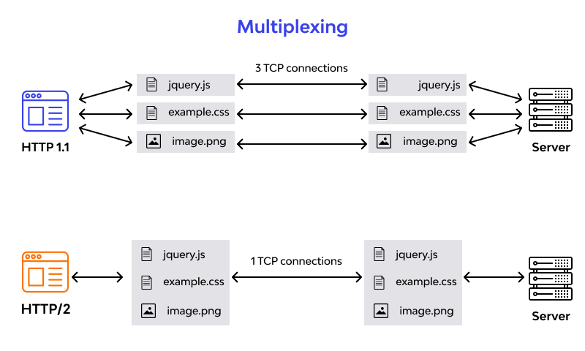

**Server push:** Typically, a server only serves content to a client device if the client asks for it. However, this approach is not always practical for modern webpages, which often involve several dozen separate resources that the client must request. HTTP/2 solves this problem by allowing a server to "push" content to a client before the client asks for it. The server also sends a message letting the client know what pushed content to expect – like if Bob had sent Alice a Table of Contents of his novel before sending the whole thing.

**Header compression:** Small files load more quickly than large ones. To speed up web performance, both HTTP/1.1 and HTTP/2 compress HTTP messages to make them smaller. However, HTTP/2 uses a more advanced compression method called HPACK that eliminates redundant information in HTTP header packets. This eliminates a few bytes from every HTTP packet. Given the volume of HTTP packets involved in loading even a single webpage, those bytes add up quickly, resulting in faster loading.

## **Conclusion:**

Choosing the right protocol for your website is crucial to enhancing performance and user experience. While HTTP/1.1 has served websites well for many years, the transition to HTTP/2 offers significant improvements in speed, efficiency, and security. By assessing your web server's compatibility, optimizing configurations, and prioritizing HTTPS implementation, you can unlock the full potential of HTTP/2. Remember to monitor performance metrics continuously to gauge the impact of the protocol on your website. Ultimately, embracing HTTP/2 can provide a competitive edge in today's digital landscape by delivering faster loading times, improved resource handling, and enhanced security features. Make an informed decision to propel your website towards greater success.